OPERATING SYSTEMS ASSIGNMENT

Name : A.SriHarsha
Roll.No : A03
Reg.No : 11609450
Section : K1622
Group : 1
Allotted Question : 3,24
Github link: https://github.com/sriharsha15/osproject-k1622-A03-q3-24/upload/master

Question: Consider the following and generate a solution to find whether the system is in safe state or not ?

Safety Algorithm:

1) Let Work and Finish be vectors of length ‘m’ and ‘n’ respectively.
Initialize: Work = Available
Finish[i] = false; for i=1, 2, 3, 4….n

2) Find an i such that both
a) Finish[i] = false
b) Needi <= Work if no such i exists goto step (4)

3) Work = Work + Allocation
Finish[i] = true
goto step (2)

4) if finish [i] = true for all i
then the system is in a safe state

Resource-Request Algorithm:

1) If Requesti <= Needi
Goto step (2) ; otherwise, raise an error condition, since the process has exceeded its maximum claim.

2) If Requesti <= Available Goto step (3); otherwise, Pi must wait, since the resources are not available.

3) Have the system pretend to have allocated the requested resources to process Pi by modifying the state as
follows:
Available = Available – Requesti
Allocationi = Allocationi + Requesti
Needi = Needi– Requesti

Code For The Program:

#include<stdio.h>
int main()
{
int p, allocation[10], max[10], need[10], available,i,j,flag[10],x=0,sequence[10],c=0;
printf("Enter the number of process \n");
scanf("%d",&p);
for (i=0;i<p;i++)
{
flag[i]=0; //initially no process's need is fulfilled
}
for(i=0;i<p;i++)
{
printf("Enter the allocation for process P[%d]\n",i);
scanf("%d",&allocation[i]);
printf("Enter the max for process P[%d]\n",i);
scanf("%d",&max[i]);
}
printf("Enter the available resources");
scanf("%d",&available);
for(i=0;i<p;i++)
{
need[i]=max[i]-allocation[i];
}
for(i=0;i<p;i++)
{
printf("Need of P[%d] is %d\n",i,need[i]);
}
for(i=0;i<p;i++)
{
for(j=0;j<p;j++)
{
if(flag[j]==0&&need[j]<=available)
{
available=available+allocation[j];
flag[j]=1;
printf("Process %d has been allocated resources\n",j);
sequence[c]=j;
c++;
}
}
}
for(i=0;i<p;i++)
{
if(flag[i]==0)
{
printf("system is in unsafe state\n");
x=1;
break;
}
}
if(x==0)
{
printf("System is in safe state\n");
printf("Safe sequence is \n");
for(i=0;i<p;i++)
{
printf("P[%d],",sequence[i]);
}
}
printf("\n");
}

Output:

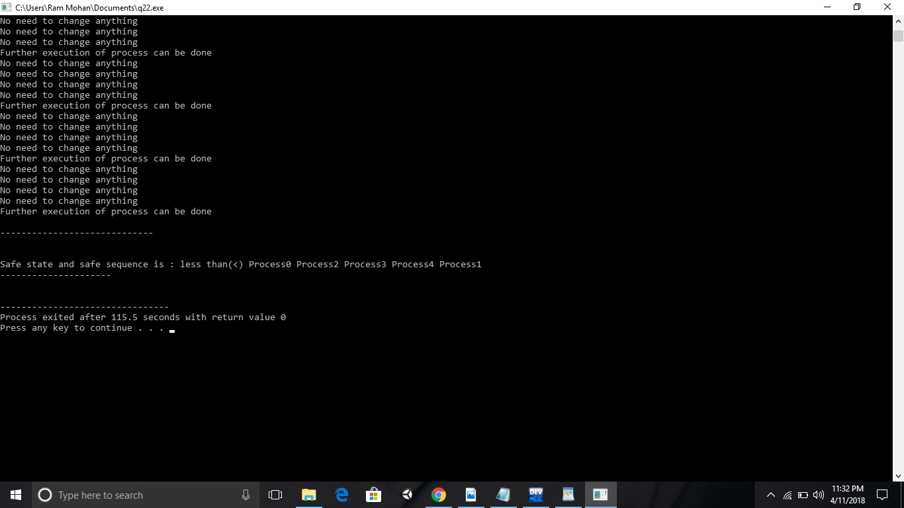

In this scenario we use bankers algorithm

3. Write a multithreaded program in C that outputs prime numbers. This program should work as follows: The user will run the program and will enter a number on the command line. The program will then create a separate thread that outputs all the prime numbers less than or equal to the number entered by the user.

CODE FOR ALGORITHM:

#include<stdio.h>
#include<pthread.h>
void *function1();
int main()
{
pthread_t thread1;
pthread_create(&thread1,NULL,function1,NULL);
pthread_join(thread1,NULL);
}

void *function1()
{
int l,i,temp=0,p,t;
printf("Enter the limit:");
scanf("%d",&l);
int list[l];
for(i=2;i<=l;i++){
list[temp]=i;
temp++;
}
for(i=0;i<temp;i++){
if(list[i]!=0){
t=i;
p=list[i];
while((t+p)<temp){
t=t+p;
list[t]=0;
}
}
}
for(i=0;i<temp;i++){
if(list[i]!=0)
printf("%d, ",list[i]);
}
}

Scenario:

IN THIS WE USE multithreaded concept

